***Data Science – Exploratory Data Analysis and Visualization***

Git Tutorial - Git is a version control system

(skip to ‘**Create a repository**’ if you already have an account/are logged in with BitBucket)

--**Create an account**

Create an account

https://bitbucket.org/account/signup/

--**Create a repository**

This is where you will store your work, you can really store ANYTHING --- really, anything, although most people will use it just for code

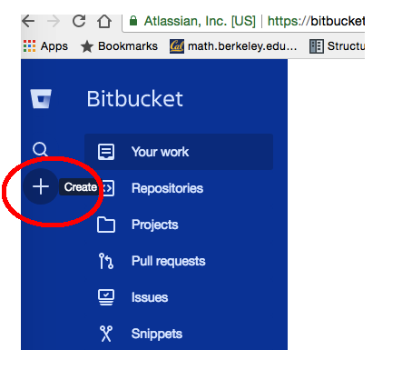

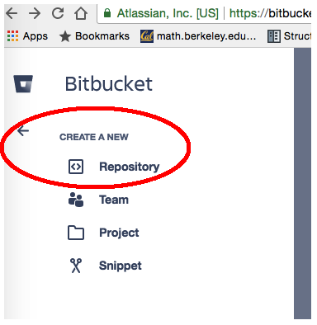

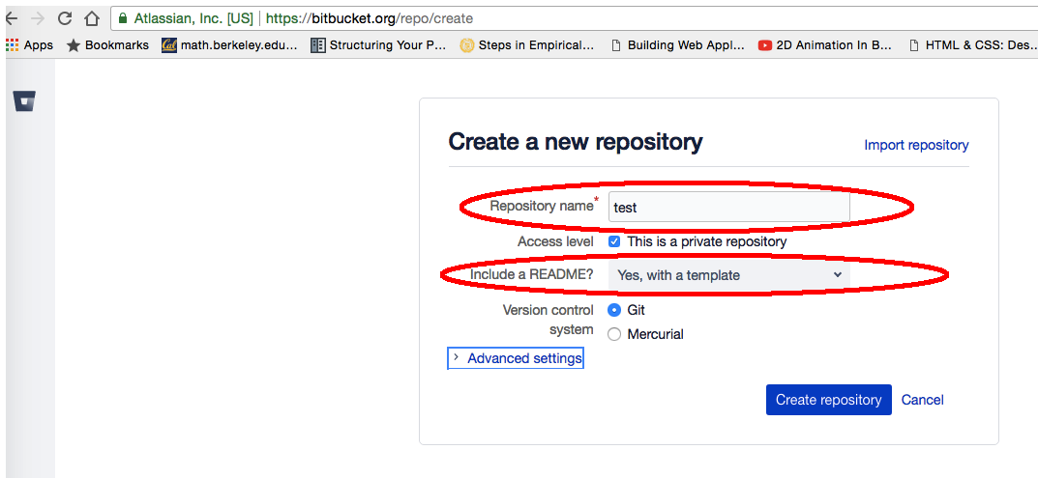

Click create repository

--Install GIT on your computer

<https://www.atlassian.com/git/tutorials/install-git>

--**Access/navigate/use your repository**

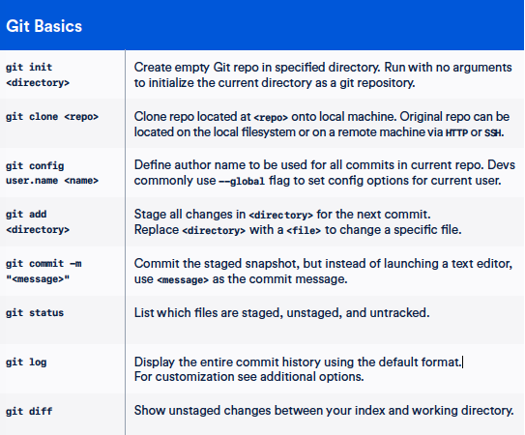

(Source: Atlassian, https://www.atlassian.com/git/tutorials/atlassian-git-cheatsheet)